Welford and Weston Local History Society
(www.welfordandweston.org.uk)

Newsletter 89 – October 2023

‘Scratching the surface’ – medieval graffiti in Warwickshire Churches
An illustrated talk given by David Freke
24 November 2023, at 7:30 pm in Welford Memorial Hall
(also available via Zoom)

This talk will explore the graffiti which can be found in local churches. Are they sacred or profane, or both? Or neither? Where are they in a church? When were they made? And by whom? And what with? Recent research has begun to suggest some answers, but much remains obscure. Even finding some graffiti is a challenge whereas other examples are in plain sight, but are often overlooked. How have attitudes changed to such informal mark-making and what can that tell us about the social and religious context?

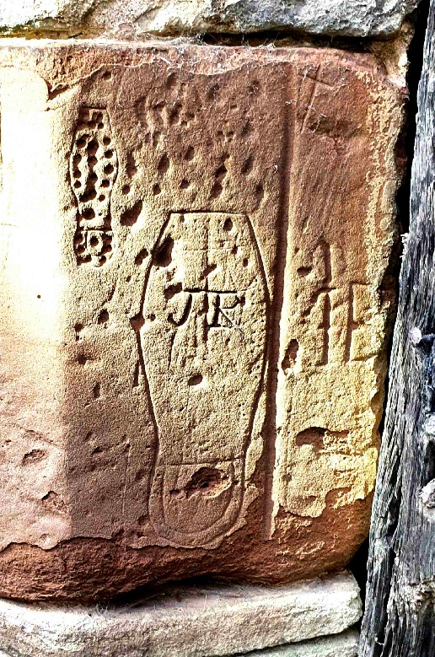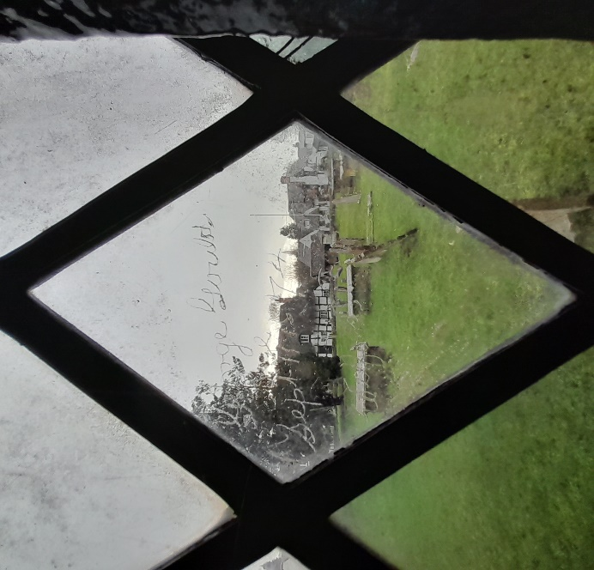

The talk will be illustrated with examples from the local area.
The presentation will last for around 50 minutes, after which there will be an opportunity to ask questions.
This talk will be available to people attending in person in the village Memorial Hall, as well as available remotely via Zoom. The choice is yours.
You will receive an email from Karen Dickinson, inviting you to join this meeting, about a week before the meeting itself. This email is being sent to all members, whether or not you will be going to the Memorial Hall or viewing remotely via Zoom. Please check in your junk folder if you don't receive it.
On the evening of the talk, you will be able to join the meeting by Zoom from 19:00. The talk itself will start at 19:30. If you are fairly new to Zoom, I would encourage you to join the meeting early, so that if you experience a problem, you'll have time to call Karen Dickinson (on 07970 179821), and get it sorted out before the talk starts at 19:30. If you are going to attend in person, the doors of the Memorial Hall, are open from 19:10. We look forward to warmly welcoming you to the third talk of our new Season on 24th November.

Kind regards, Brad Plimmer 27 October, 2023.

